a.

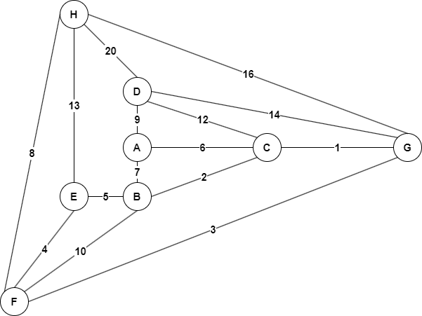

b.

|  |  |  |  |  |  |  |  |  |
| --- | --- | --- | --- | --- | --- | --- | --- | --- |
| Đỉnh | A | B | C | D | E | F | G | H |
| 1 | - | (A,7) | **(A,6)** | (A,9) | x | x | x | x |
| 2 | - | (C,2) | - | (A,9) | x | x | **(C,1)** | x |
| 3 | - | **(C,2)** | - | (A,9) | x | (G,3) | - | (G,16) |
| 4 | - | - | - | (A,9) | (B,5) | **(G,3)** | - | (G, 16) |
| 5 | - | - | - | (A,9) | **(F,4)** | - | - | (F,8) |
| 6 | - | - | - | (A,9) | **-** | - | - | **(F,8)** |
| 7 | - | - | - | **(A,9)** | **-** | - | - | - |
| 8 | - | - | - | - | **-** | - | - | - |

TỔNG TRỌNG SỐ: 33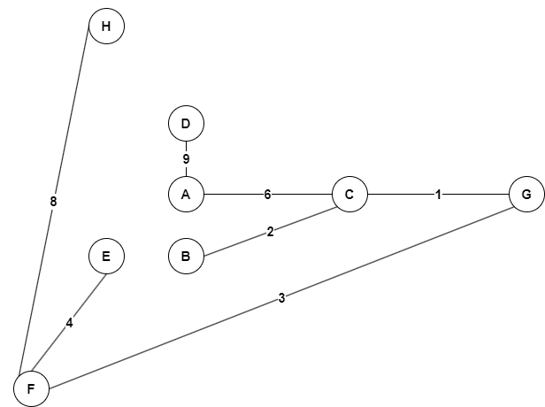

c.

|  |  |  |  |
| --- | --- | --- | --- |
| **LẦN CHỌN** | **CẠNH** | **TRỌNG SỐ** | **ĐỈNH** |
| 1 | C-G | 1 | C, G |
| 2 | B-C | 2 | B, C, G |
| 3 | G-F | 3 | B, C, F, G |
| 4 | E-F | 4 | B, C, E, F, G |
| 5 | A-C | 6 | A, B, C, E, F, G |
| 6 | F-H | 8 | A, B, C, E, F, G, H |
| 7 | A-D | 9 | A, B, C, D, E, F, G, H |

TỔNG TRỌNG SỐ: 33

d.

|  |  |  |  |  |  |  |  |  |
| --- | --- | --- | --- | --- | --- | --- | --- | --- |
| Đỉnh | A | B | C | D | E | F | G | H |
| 1 | - | (A, 7) | **(A,6)** | (A, 9) | x | x | x | x |
| 2 | - | **(A, 7)** | - | (A, 9) | x | x | (C, 7) | x |
| 3 | - | **-** | - | (A, 9) | (B, 12) | (B, 17) | **(C, 7)** | x |
| 4 | - | - | - | **(A, 9)** | (B,12) | (G,10) | - | (G, 23) |
| 5 | - | - | - | - | (B,12) | **(G,10)** | - | (G, 23) |
| 6 | - | - | - | - | **(B,12)** | - | - | (F,18) |
| 7 | - | - | - | **-** | **-** | - | - | **(F,18)** |
| 8 | - | - | - | - | **-** | - | - | - |

Vậy đường đi ngắn nhất giữa hai đỉnh A-H có độ dài là 18: A 🡪 C 🡪 G 🡪 F 🡪 H